**Internet Banking - Loan**

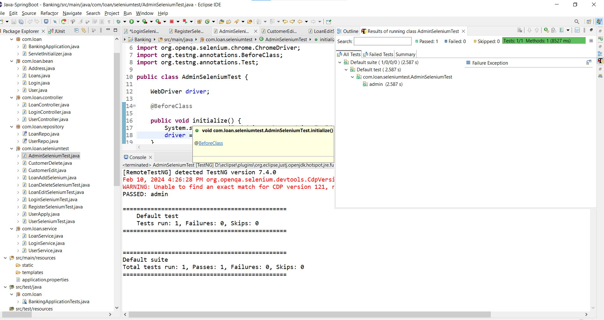

**Fig 1: Admin Home**

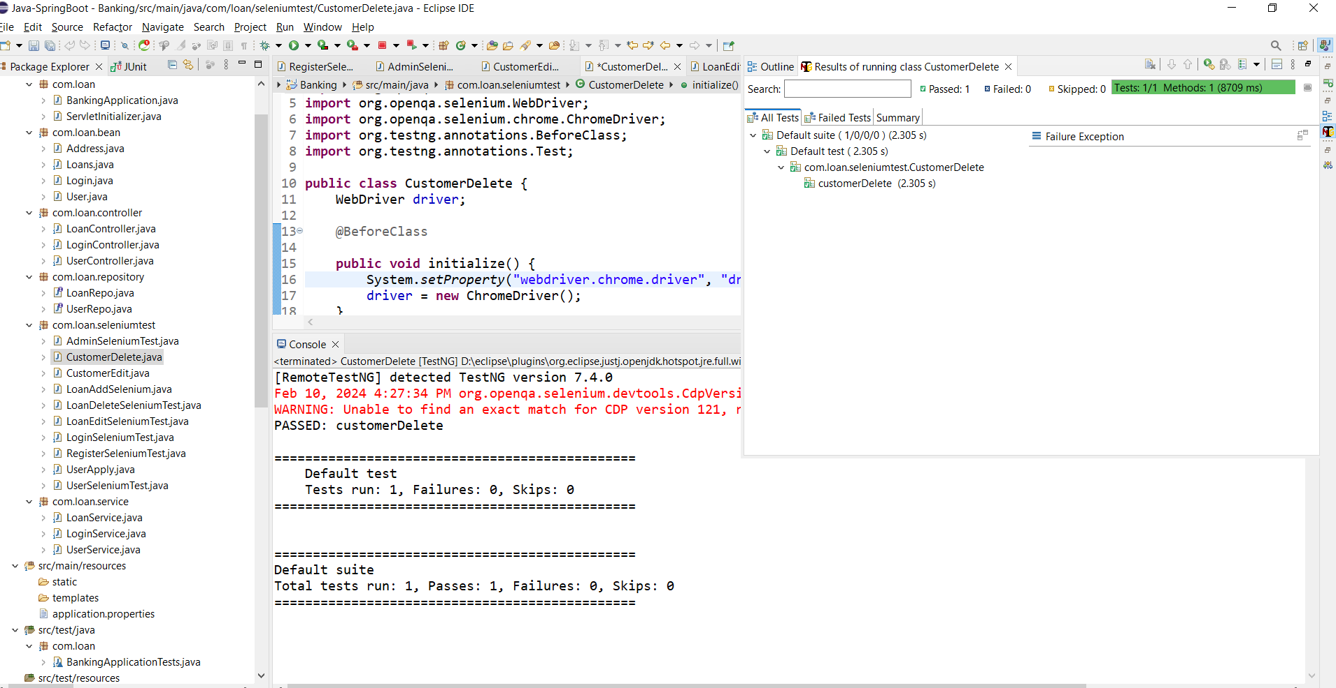

**Fig 2: Customer delete**

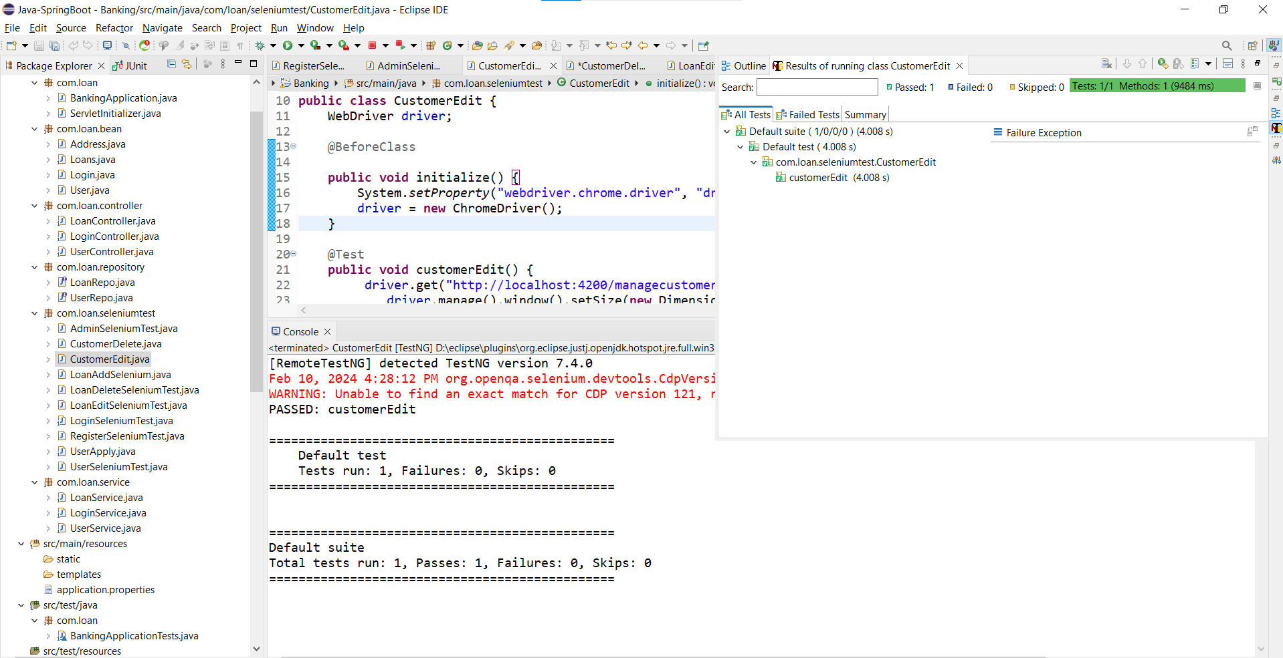

**Fig 3: Customer edit**

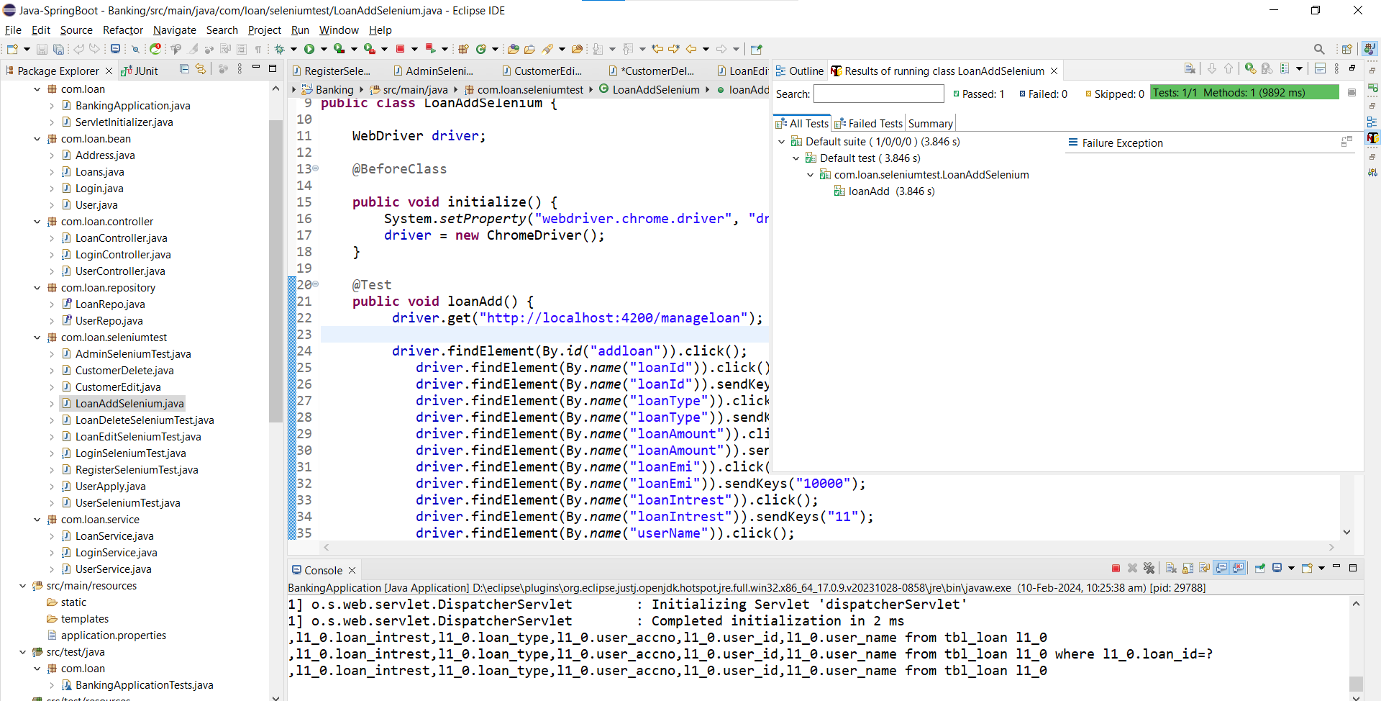

**Fig 4: Loan add**

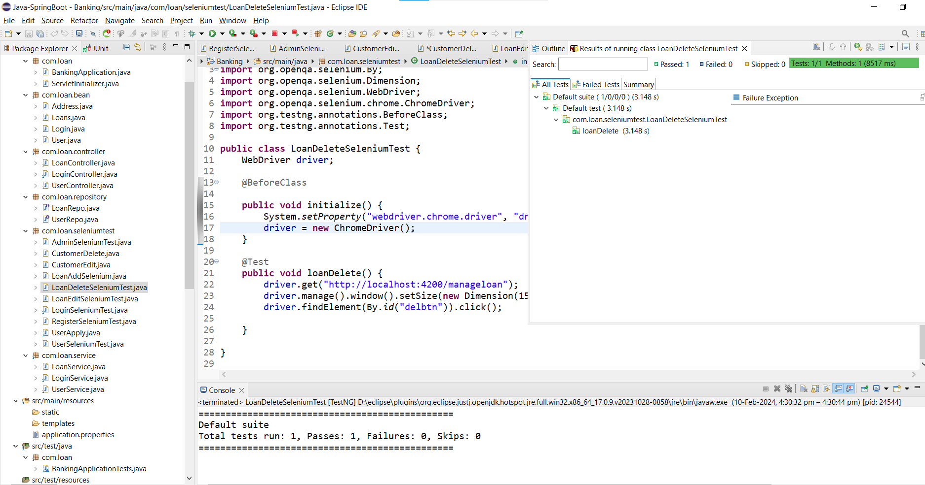

**Fig 5: Loan delete**

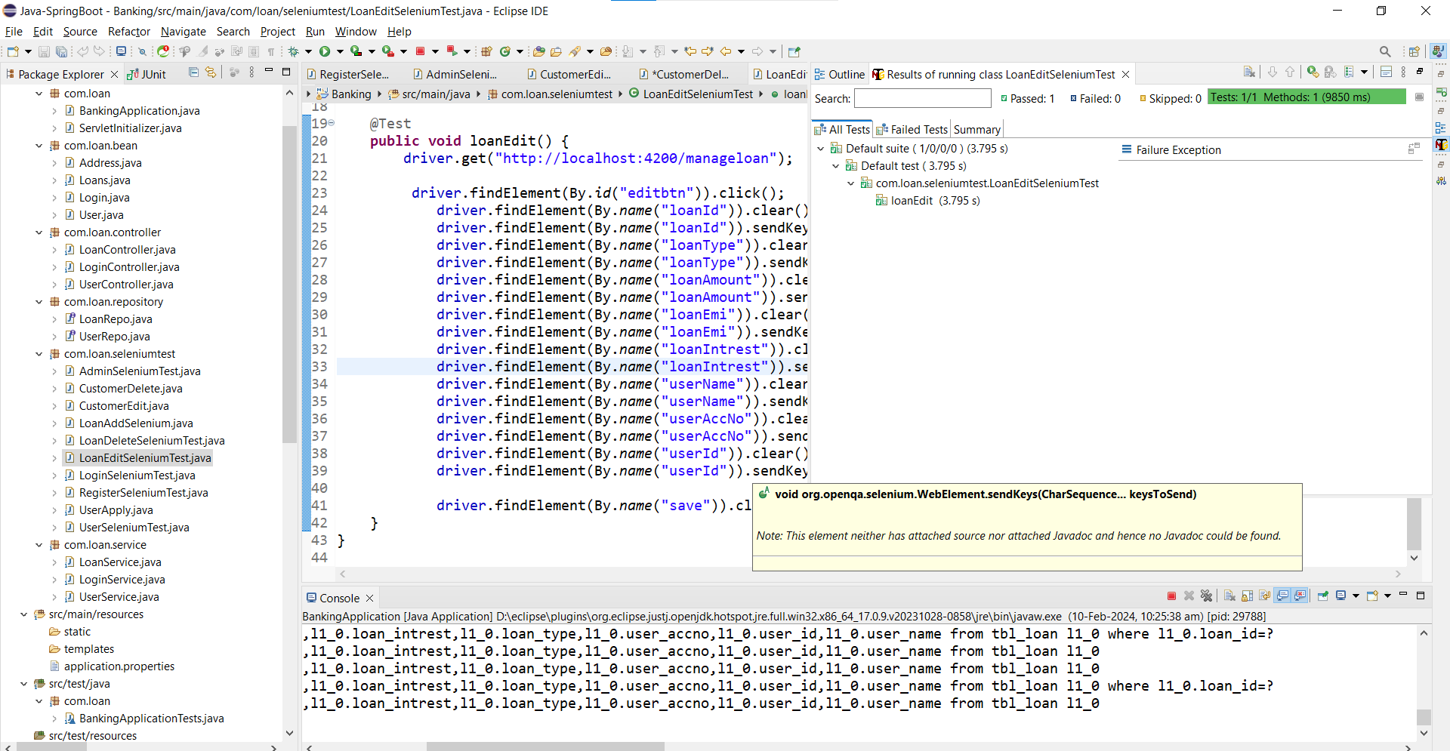

**Fig 6: Loan edit**

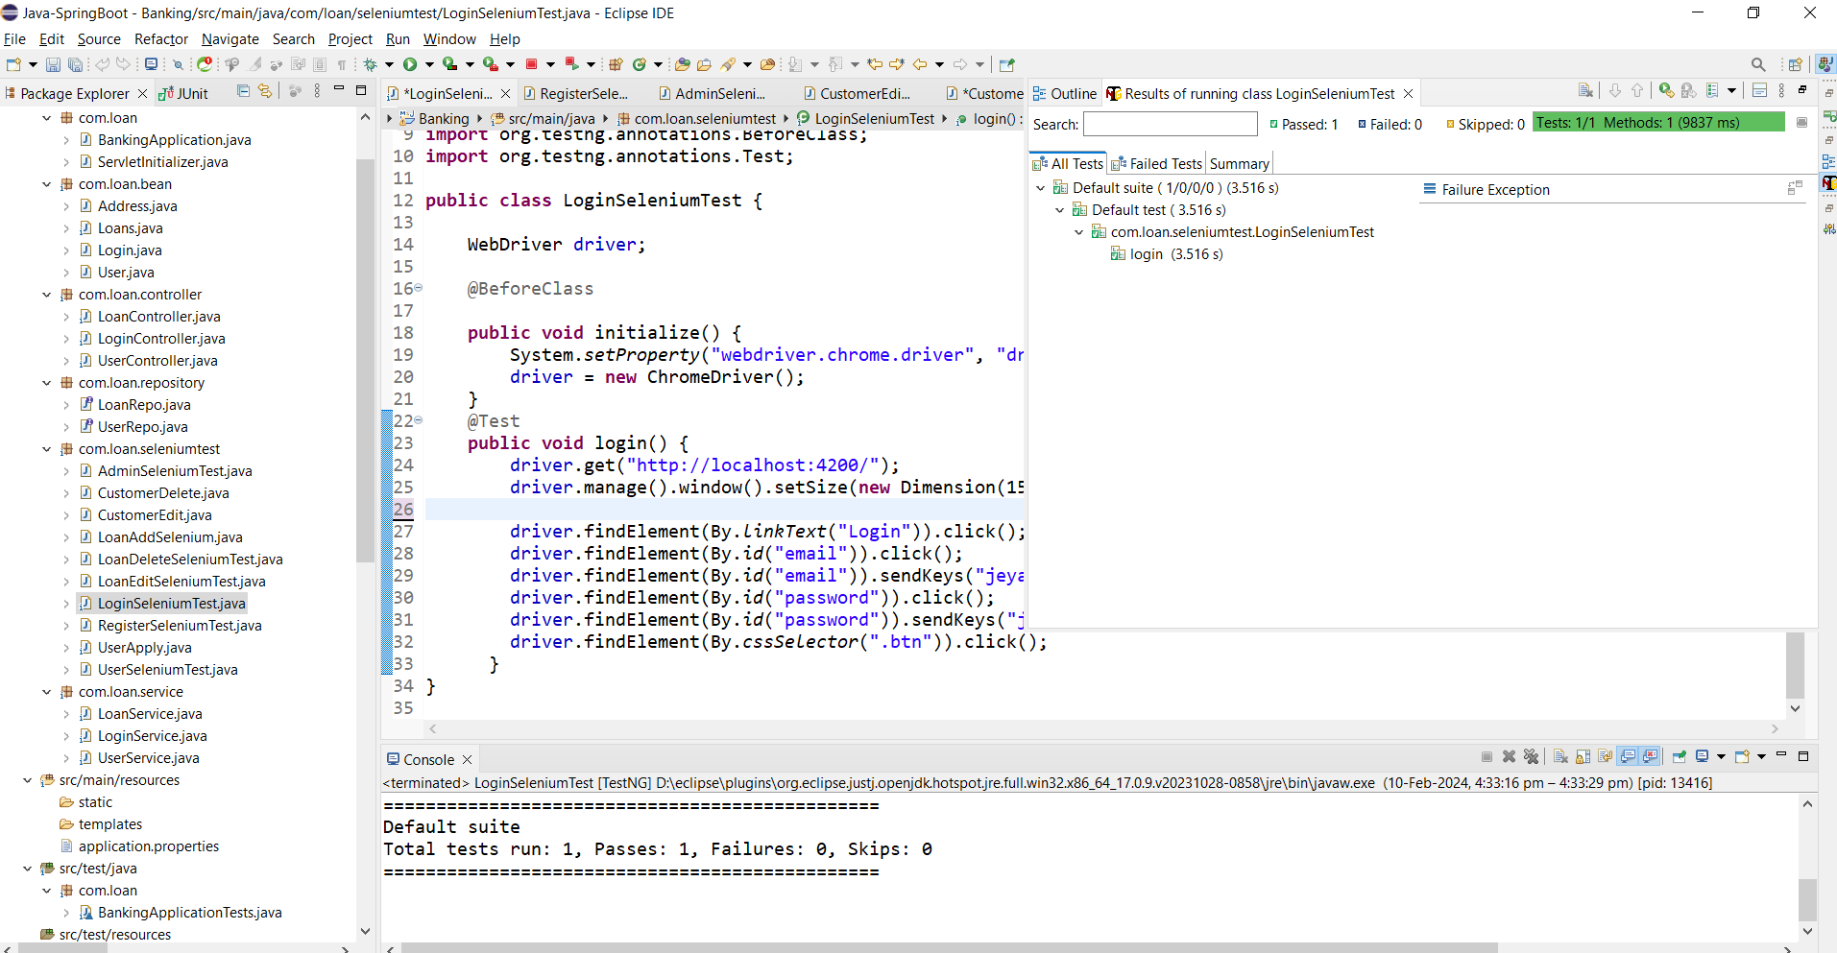

**Fig 7: Login**

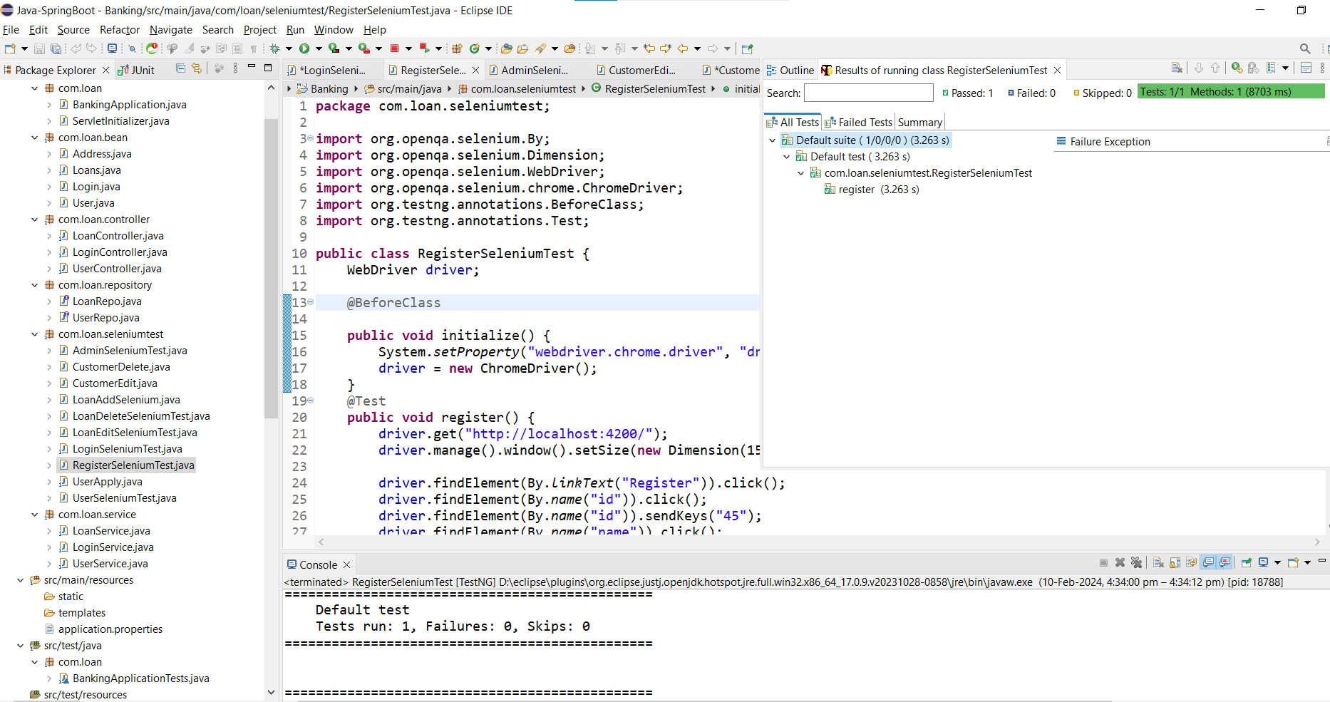

**Fig 8: Register**

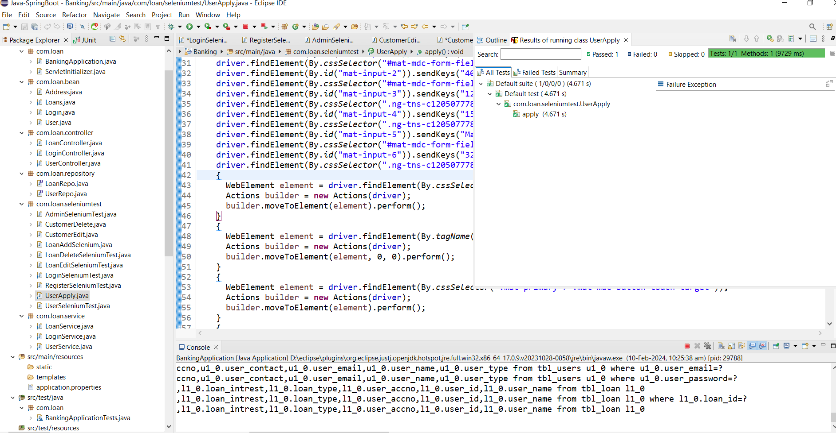

**Fig 9: Apply loan**

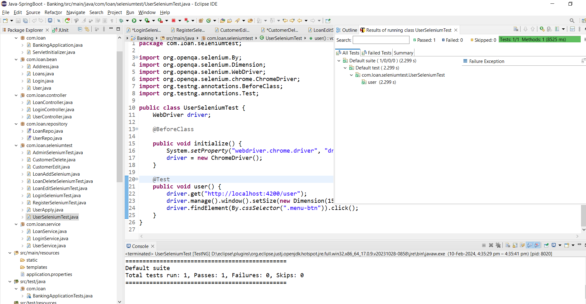

**Fig 10: User home**